AI-Ready Data

Introduction
Most AI projects don't fail because of the model. They fail because of the data.
Despite growing investment in AI infrastructure, a 2024 survey by the IBM Institute for Business Value found that only 29% of technology leaders strongly agree their enterprise data meets the quality, accessibility, and security standards needed to efficiently scale generative AI. At the same time, Gartner notes that there are fundamental differences between traditional data management requirements and what AI systems actually demand, a gap that many organizations have yet to seriously close. The concept of AI-ready data addresses both of these realities: it defines what data must look like to reliably power AI workloads, and provides a concrete framework to get there.

1. What is AI-ready data?
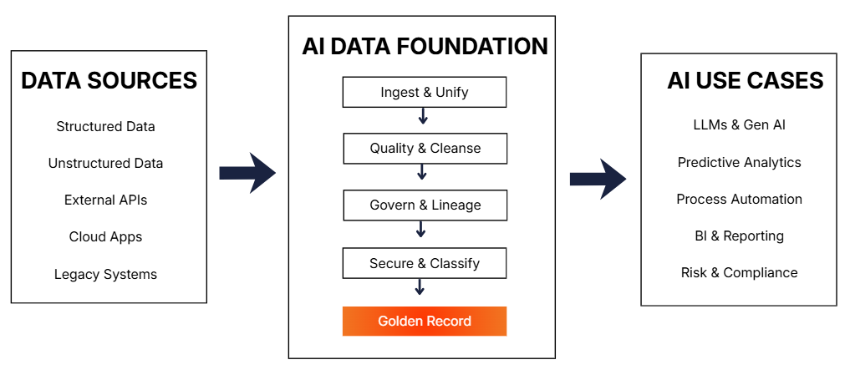

AI Data Ecosystem
AI-ready data is not merely a file format or a cloud migration target. It is a comprehensive quality standard. While many organizations focus on moving data into the right cloud bucket or converting it to a specific schema, true readiness is defined by whether the data is fit for the unique demands of machine learning and autonomous reasoning.
It operates on the core principle of "Garbage In, Garbage Out". If the input data is inaccurate, biased, or incomplete, the model's output will be unreliable at best and actively harmful at worst, producing flawed decisions or hallucinations in generative systems. Readiness, as Gartner frames it, cannot be achieved generically in advance: it is always relative to a specific use case, the AI technique being applied, and the trust level expected from the output.
Unlike traditional analytics, which often removes outliers to "clean" reports for human consumption, AI-ready data must be representative. In conventional Business Intelligence (BI), the standard move is to strip out anomalies, like a one-day spike in website traffic or a corrupted sensor reading, to provide executives with a "smooth" trend line that is easy to interpret. That makes sense for human consumption.
However, AI models work the opposite way. They need to see the world in all its messiness to learn from it. To be truly ready, data must include real-world patterns, errors, and anomalies so the model can learn from actual complexities. For instance, in Fraud Detection, the "clean" data is actually the least useful; the model needs to see the outliers, the suspicious edge cases, and the transactions that look nothing like normal behavior to understand what a crime looks like. Similarly, in Predictive Maintenance, sensor data that fluctuates wildly right before a mechanical failure is technically "low quality" by traditional standards, but for an AI, that "noise" is the critical signal it needs to save the company millions in repairs.
The scale of the problem becomes clearer when you look at unstructured data. In practice, AI-ready data must cover both structured data (transactional records in ERP and CRM systems) and unstructured data (documents, emails, PDFs, images). Unstructured data currently represents the vast majority of enterprise data, yet less than 1% of it exists in a format suitable for direct AI consumption. This structural imbalance is one of the core reasons why only 16% of AI initiatives have reached enterprise scale, according to the IBM IBV 2025 CEO Study.
AI-ready data is therefore not defined by a single attribute, but by the simultaneous presence of four foundational conditions: it must be unified and accessible, governed, secure, and supported by the right tooling and skills. These conditions collectively determine whether data can be trusted as input for AI systems, and whether the outputs of those systems can in turn be trusted by the organization.

2. How do I get my data AI-ready?

Preparing data for systems like LLMs requires a rigorous process to ensure the information is not just available, but contextually rich. This is achieved through a Data Readiness Pipeline:

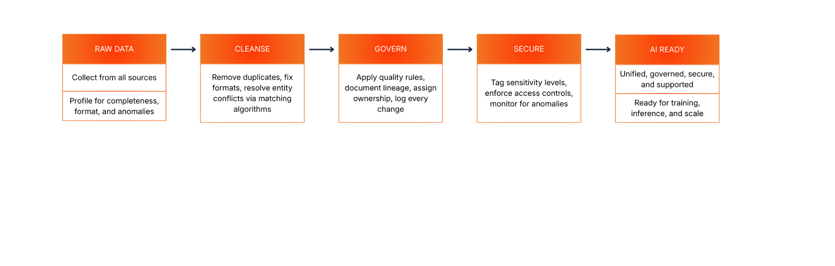

2.1 Challenges

Picture this: you are three months into an AI initiative. The model is ready. The infrastructure is provisioned. Then someone asks, “Is our data actually ready for this?” You pull up the inventory. There is customer data in Salesforce, transaction records in SAP, product specs scattered across spreadsheets, support tickets living in a third-party helpdesk, and a data lake that was set up two years ago, and nobody is quite sure what is in it anymore. Different update cycles. Different owners. Nobody has a complete picture, and the project timeline is not getting any longer.

That scenario is not hypothetical. Data sprawl and fragmentation remain the most pervasive obstacles in enterprise AI projects. In a typical organization, data is distributed across legacy ERP systems, cloud SaaS platforms, departmental databases, and third-party APIs, each with its own structure, governance, and access model. This fragmentation makes unified access difficult to establish and consistency nearly impossible to enforce, which is precisely what AI workloads require most.

Poor data quality in AI is not what most teams think it is. Duplicate records, missing values, and inconsistent formats are well-understood problems. What is less commonly recognized is that traditional quality standards can be actively misleading in an AI context: cleaning out outliers and edge cases can remove exactly the variance that a classification or anomaly detection model needs to learn from. A fraud detection model trained on “clean” data, where every unusual transaction was removed during preprocessing, will perform beautifully on historical records and fall almost immediately in production. Data teams need to rethink quality not as an absolute standard, but as a use-case-specific requirement.

The skills gap is where timelines quietly collapse. Data engineering teams are frequently stretched between maintaining existing infrastructure and delivering clean, labeled datasets for AI projects on compressed timelines. Many data teams lack hands-on experience with vector databases, embedding pipelines, retrieval-augmented generation (RAG) architectures, or the data annotation workflows that modern AI systems depend on. Semantic labeling and annotation, particularly for image, video, and document data, is a critical capability that most organizations are underprepared for.

Unstructured data makes this harder in a structurally different way. Documents, emails, PDFs, images, and chat logs collectively hold the richest operational context in most organizations, the kind of institutional knowledge that never makes it into a structured database. Yet the overwhelming majority of it sits in formats that AI models cannot directly consume. Ignoring this layer means training models on a narrow slice of what the organization actually knows. Capturing it requires dedicated preprocessing pipelines, vectorization, and metadata enrichment workflows that most data teams simply have not built yet, and that the existing infrastructure was never designed to support.

Then there is the regulatory dimension, and it scales with your AI. As AI systems increasingly process sensitive information, such as customer profiles, financial records, and health data, the exposure surface grows with every deployment. Generative AI specifically introduces new attack vectors that traditional security models were not built for: prompt injection, unintended data leakage through model outputs, and the risk of sensitive context being surfaced through retrieval pipelines. Organizations scaling AI without mature data governance are not just taking on technical debt. They are accumulating regulatory and reputational risk in parallel with every model they ship. Under the EU AI Act, penalties for regulatory violations can reach EUR 35 million or 7% of global annual turnover, whichever is higher. Gartner additionally flags data bias and fairness as a governance obligation, not just a model tuning concern, meaning data stewardship policies must actively address representativeness and diversity of training data sources before a model ever reaches production.

2.2 Benefits
Now flip the picture. What does it look like when an organization actually gets this right?

AI-ready data delivers compounding returns, not just a one-time quality improvement. Consider a retail company that has spent 18 months building a governed product catalog: unified across ERP, ecommerce, and supply chain systems, with consistent taxonomy, version history, and access controls embedded at the data layer. Once that foundation is in place, they are not just running a better product search. That same catalog powers demand forecasting, personalized recommendation engines, and inventory optimization algorithms, all simultaneously, without duplicating the underlying data work. The effort compounds. Each new AI initiative costs less than the last because the data infrastructure is already there.

The most immediate return is stronger model performance. Clean, consistently formatted, use-case-appropriate, and well-labeled data reduces hallucinations in LLMs, improves classification accuracy in predictive models, and accelerates convergence during training. This directly translates to faster development cycles. When teams no longer need to spend the majority of their time on data cleaning and reconciliation, they can focus on model development, evaluation, and iteration.

Governance and compliance confidence is the second major payoff. Embedded quality controls, lineage tracking, versioning, and documented access policies mean that AI systems can be audited, explained, and defended to regulators. That is a hard requirement in financial services, healthcare, pharmaceuticals, and any sector subject to GDPR, BCBS 239, or the EU AI Act. This also requires continuous regression testing and data drift monitoring as part of this: AI-ready data must remain valid not just at training time, but throughout the operational life of the model.

At scale, the strategic value becomes a force multiplier. Once data assets are properly unified, governed, and secured, they become a shared infrastructure layer that multiple AI workloads can draw from simultaneously, without duplication of effort. This reusability generates economies of scale in AI deployment and turns high-quality data from a project cost into a durable organizational asset. This is also why the right way to think about this ends with "scale and govern" rather than "deploy and finish." Sustainable AI-readiness is a continuous operational capability, not a project milestone.

2.3 Cheat Sheet
The table below summarizes the core characteristics that define AI-ready data and the significance of each in the context of AI systems deployment. The first three columns reflect widely accepted data readiness attributes from IBM and Gartner. The Gartner-specific notes in the final column reflect the use-case-dependent perspective that distinguishes AI readiness from general data quality.
Characteristic | Description | Significance for AI
Unified & Accessible | Data from disparate sources is consolidated into a single, queryable view across databases, data lakes, and cloud apps. | AI models cannot act on data they cannot reach. Fragmented access limits context, coverage, and cross-domain reasoning.
Use-Case Fit | Data is evaluated and validated against the specific requirements of each AI use case, including volume, diversity, and technique. | Gartner: There is no generic AI-readiness. A dataset appropriate for one model may be unsuitable or actively harmful for another.
Accurate & Complete | Records are free of errors, duplicates, and missing fields. Data quality scores are actively measured and enforced. | Inaccurate or incomplete training data directly produce unreliable, biased, or misleading model outputs.
Representative & Diverse | Data covers the full range of patterns, edge cases, and outliers relevant to the AI task, including those filtered out by traditional quality standards. | Gartner: Cleaning out outliers can remove variance that classification and anomaly detection models require. Diversity of sources prevents training bias.
Governed | Clear ownership, quality rules, lineage tracking, versioning, and approval workflows are defined and enforced across the data lifecycle. | Enables auditability, regulatory compliance (GDPR, EU AI Act, BCBS 239), and the long-term sustainability of data quality.
Secure | Role-based access controls, data masking, and privacy enforcement are embedded at the data layer, not bolted on afterward. | Protects sensitive data from exposure through AI queries or model outputs; required for compliance in regulated industries.
Current & Versioned | Data is regularly updated and time-stamped. Stale records are flagged. Version history is maintained to detect and manage model drift. | AI systems operating on outdated data produce decisions that no longer reflect operational reality. Versioning enables regression testing and drift detection.
Labeled & Annotated | Data is tagged, semantically annotated, and formatted for AI consumption, including unstructured content like documents and images. | Gartner: Labeling quality, especially for image, video, and document data, is a critical and often underestimated prerequisite for supervised learning and LLM grounding.
Supported | Tooling, pipelines, and skilled personnel are in place to monitor, orchestrate, validate, and continuously improve data quality. | AI-readiness degrades without ongoing human oversight, engineering support, observability metrics, and automated quality monitoring.

Conclusion

AI-ready data is not a one-time deliverable. It is a continuous operational capability. The organizations most likely to succeed with AI are those that treat data quality, governance, security, and accessibility not as pre-project checkboxes, but as engineering disciplines embedded into their data infrastructure from the ground up. As Gartner makes clear, this also means moving away from the notion of a single universal data standard: readiness must be assessed, validated, and governed relative to each specific AI use case and the trust levels it demands.

The path forward is structured but not simple: assess current readiness honestly, secure executive alignment early, close the gap between traditional data management and AI-specific requirements, and build the governance and tooling to sustain quality as models scale. Organizations that achieve this will not just run better AI models. They will build the data infrastructure that makes every future AI initiative faster, cheaper, and more reliable than the last.

https://www.canva.com/design/DAHC5X7RmmE/rO35bGYWLsGv13yU1yvwbQ/edit?utm_content=DAHC5X7RmmE&utm_campaign=designshare&utm_medium=link2&utm_source=sharebutton

References:
• https://www.ibm.com/think/topics/ai-ready-data
• https://www.gartner.com/en/articles/ai-ready-data

